# 

***STUDENT PORTFOLIO***



Name: Rishi Makharia

Reg. No.: RA2011031010032

E-Mail ID: rm1934@srmist.edu.in

Department: CSE

Specialization: IT

Semester: V

**Subject title**:

18CSC302J Computer Networks

**RECORD FILE**

**https://drive.google.com/file/d/1HtMtXg1gY5eV4O1lCRBJKPNgP9KA4Evu/view?usp=sharing**

**MINI PROJECT**

https://drive.google.com/file/d/1crYuuO4dhX8DjVoLRtFllF623fgyR_qh/view?usp=sharing

**AWS COURSE CERTIFICATE AND BADGE**



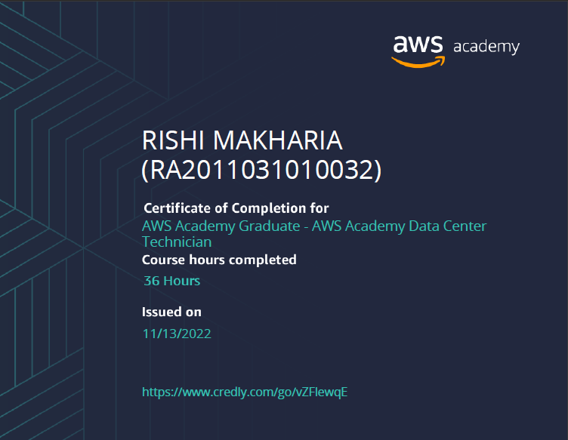

# **Hackerank Certificate**

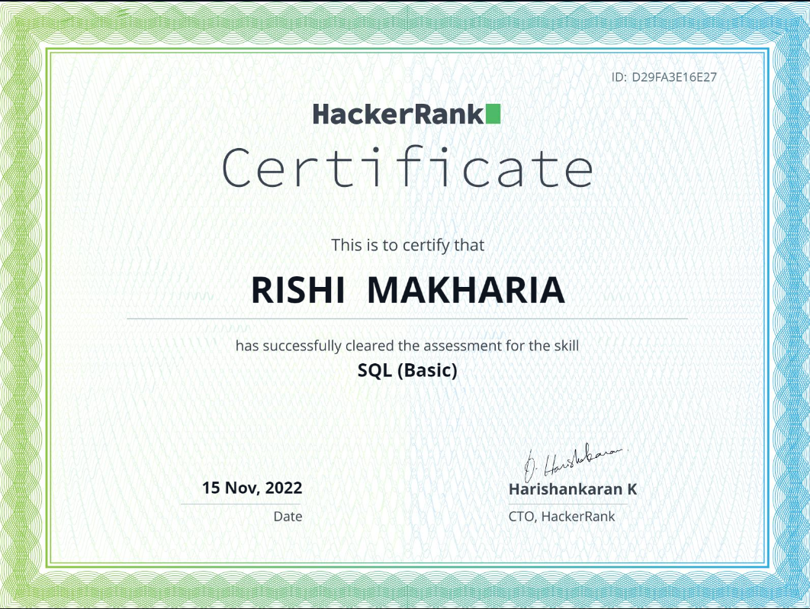

**MOOC Certificate**

# 